- Display the name of emp name who earns highest salary.
SELECT ename
FROM employee
WHERE sal = (SELECT MAX(sal) FROM employee);
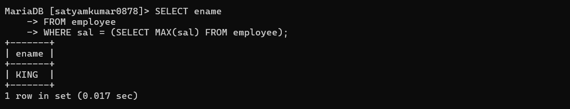
- Display the employee number and name of employee working as clerk and earning highest salary among clerks.
SELECT empno, ename
FROM employee
WHERE job = 'CLERK'
AND sal = (SELECT MAX(sal) FROM employee WHERE job = 'CLERK');

- Display the names of the salesman who earns a salary more than the highest salary of any clerk.
SELECT ename
FROM employee
WHERE job = 'SALESMAN'
AND sal > (SELECT MAX(sal) FROM employee WHERE job = 'CLERK');
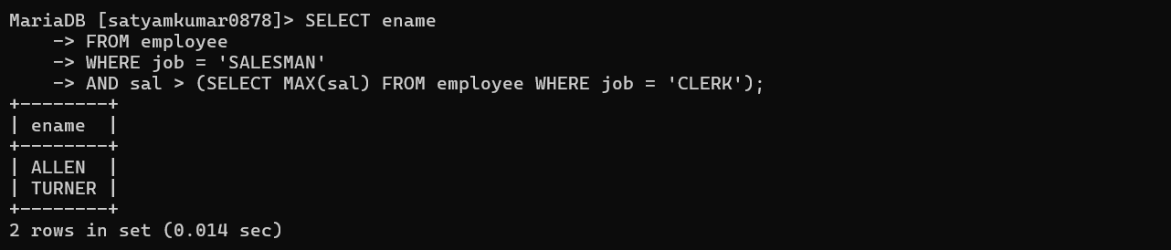
- Display the names of clerks who earn salary more than that of james of that of sal lesser than that of scott
SELECT ename
FROM employee
WHERE job = 'CLERK'
AND sal > (SELECT sal FROM employee WHERE ename = 'JAMES')
AND sal < (SELECT sal FROM employee WHERE ename = 'SCOTT');
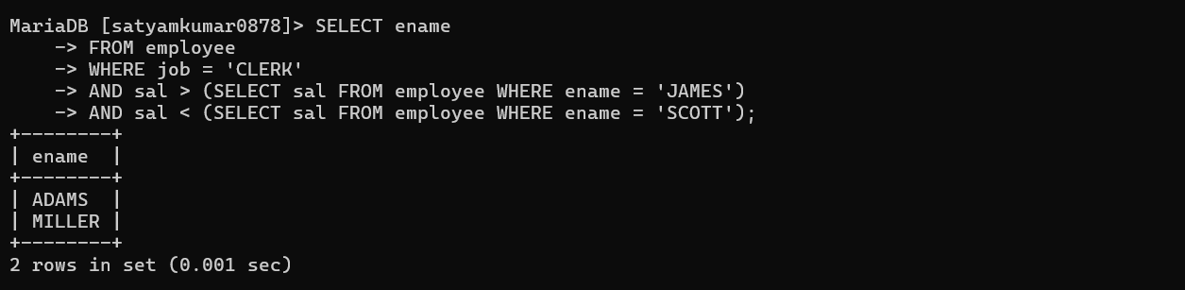
- Display the names of employees who earn a sal more than that of james or that of salary greater than that of scott.
SELECT ename
FROM employee
WHERE sal > (SELECT sal FROM employee WHERE ename = 'JAMES')
OR sal > (SELECT sal FROM employee WHERE ename = 'SCOTT');
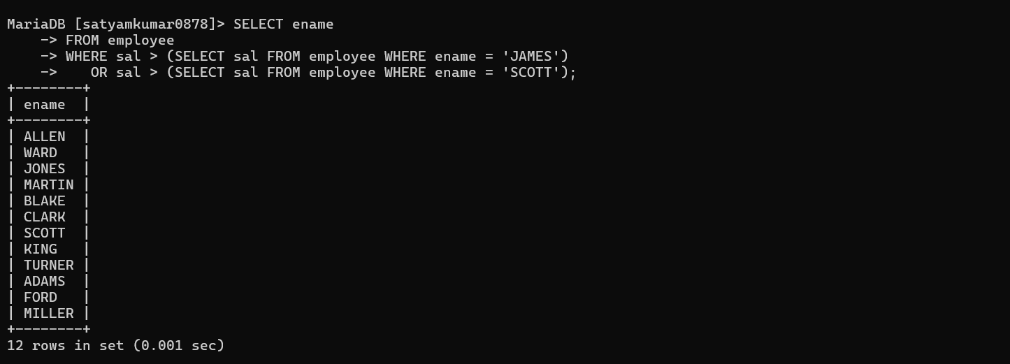
- Display the names of the employees who earn highest salary in their respective departments.
SELECT ename
FROM employee e
WHERE sal = (
SELECT MAX(sal)
FROM employee
WHERE deptno = e.deptno
);
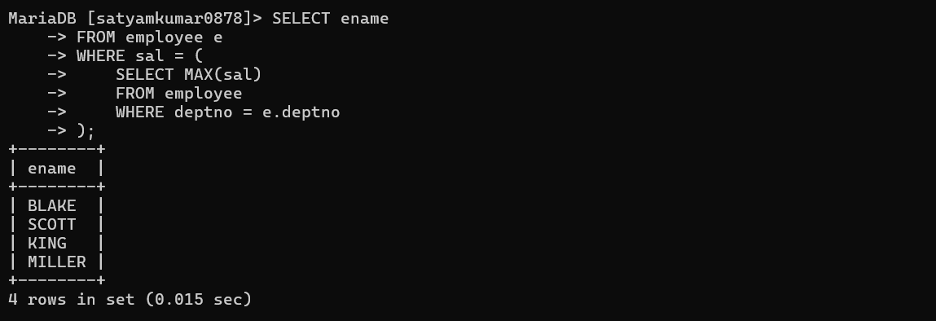
- Display the names of employees who earn highest salaries in their respective job groups.
SELECT ename
FROM employee e
WHERE sal = (
SELECT MAX(sal)
FROM employee
WHERE job = e.job
);
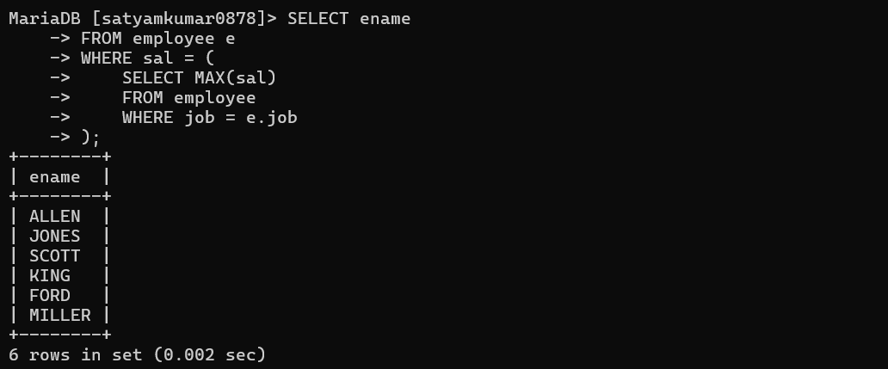
- Display the employee names who are working in accounting dept.
SELECT e.ename
FROM employee e
JOIN department d ON e.deptno = d.deptno
WHERE d.dname = 'ACCOUNTING';
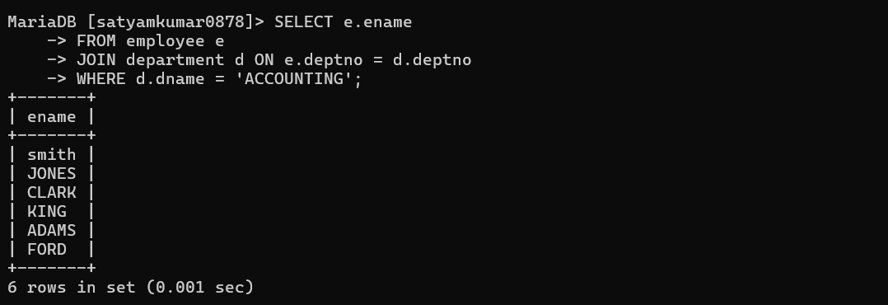
- Display the employee names who are working in mumbai.
SELECT e.ename
FROM employee e
JOIN department d ON e.deptno = d.deptno
WHERE d.LOCATION = 'mumbai';

- Display the job groups having total salary greater than the maximum salary for managers.
SELECT job
FROM employee
GROUP BY job
HAVING SUM(sal) > (
SELECT MAX(sal)
FROM employee
WHERE job = 'MANAGER'
);
